Model Development Phase Template

|  |  |
| --- | --- |
| Date | 17 JULY 2024 |
| TeamID | 740083 |
| Project Title | SENTIMENTAL ANALYSIS OF COMMODITY NEWS (GOLD) |
| Maximum Marks | 4 Marks |

**InitialModelTrainingCode,ModelValidationandEvaluationReport**

Theinitialmodeltrainingcodewillbeshowcasedinthefuturethroughascreenshot.Themodel validation and evaluation report will include classification reports, accuracy, and confusion

matrices for multiple models, presented through respective screenshots.

**Initial Model TrainingCode:**

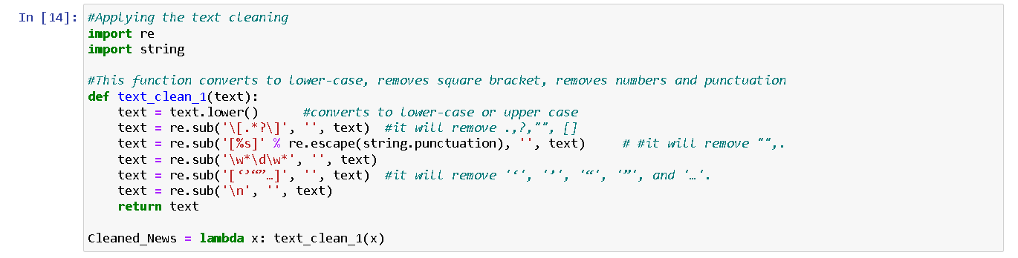

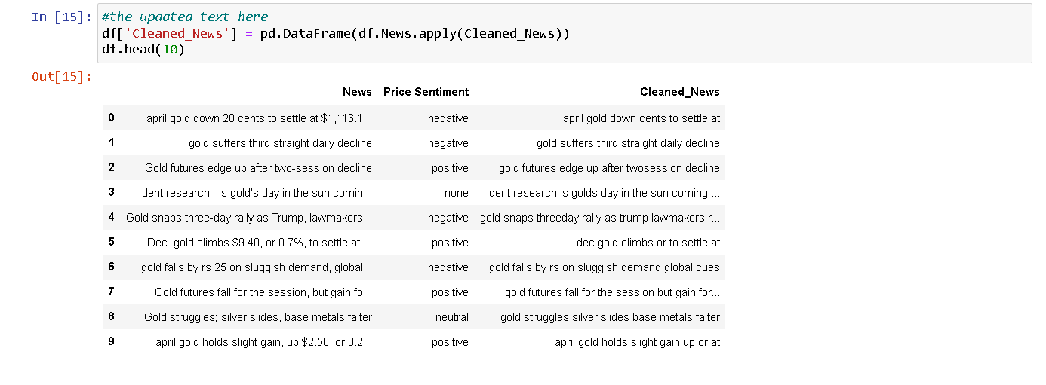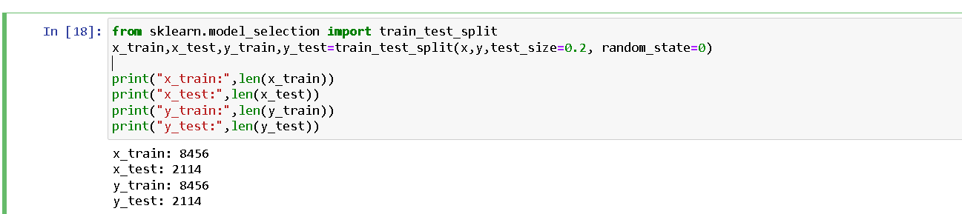

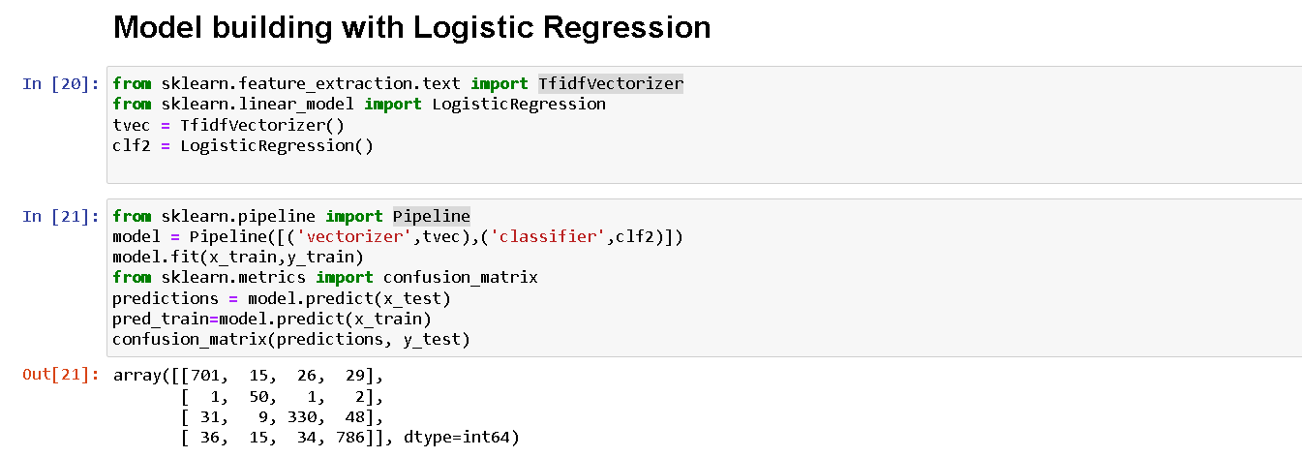

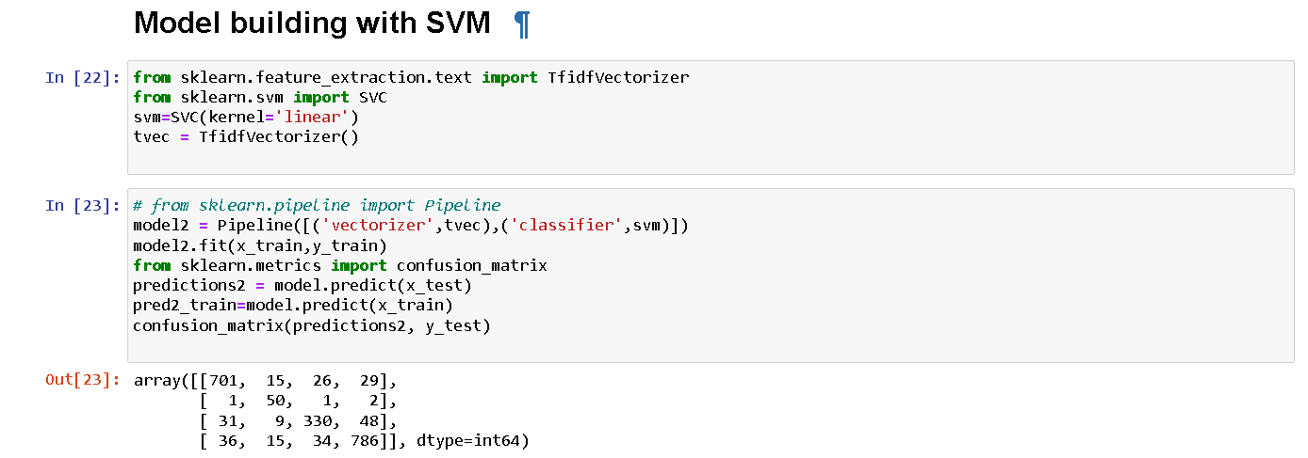

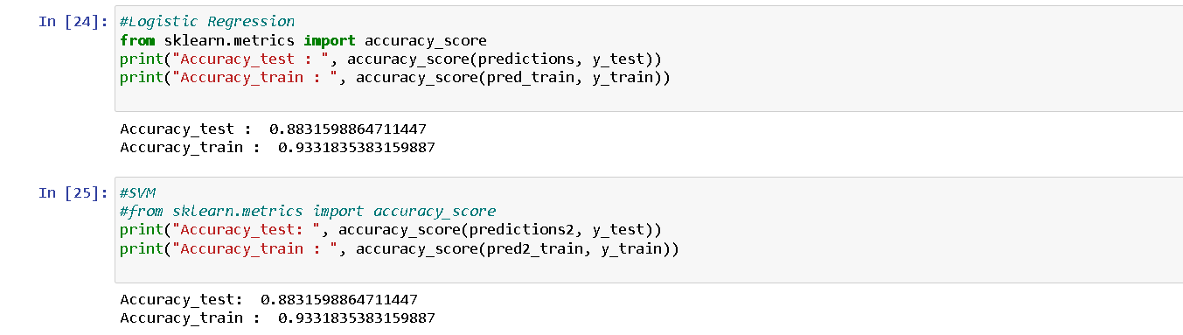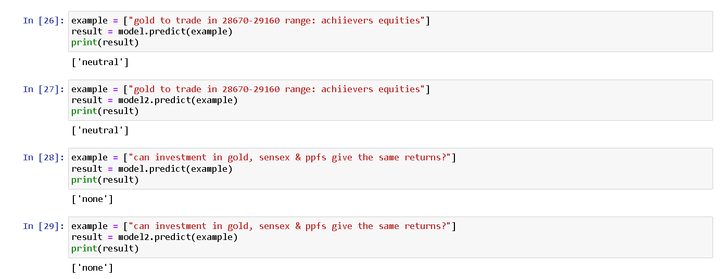

**ModelValidationandEvaluationReport:**

|  |  |  |  |
| --- | --- | --- | --- |
| **Model** | **Classification Report** | **F1**  **Scor e** | **Confusion Matrix** |
| DECISION TREE | C:\Users\DELL\Desktop\images\image18 (1).png | 88% | C:\Users\DELL\Desktop\image22.png |

|  |  |  |  |
| --- | --- | --- | --- |
| SUPPORT  VECTOR  MACHINE | https://lh4.googleusercontent.com/IDaQMbrHOrPOJtvRnNzFkhiZgGNWQBtyKLPG2bbuFeLKIiInYz46T3kvPZPrAVBjVztC1TXjgq5yWKscPj6T1-LgeBAP_PQ0eIZSWu25h17srbha1eXeBPA-lDMWCS0DHssztMTUOYypl23suBTBRA | 88% | C:\Users\DELL\Desktop\ABB.png |